Terraform Infrastructure Automation on AWS

Project Objective
Automate the provisioning and management of AWS infrastructure using Terraform. The project creates a complete cloud environment, eliminating manual configuration and ensuring consistent, repeatable deployments.

Technologies Used
- Terraform
- AWS
- Git & GitHub
- Linux (Ubuntu)
- VS Code
- AWS CLI
- IAM

AWS Services Used
- Amazon Web Services
- Amazon VPC
- Amazon EC2
- AWS Security Groups
- AWS Internet Gateway
- AWS Route Table
- AWS Elastic IP
- Amazon S3
- AWS IAM

Project Architecture
Internet

Internet Gateway

Public Subnet

EC2 Instance (Ubuntu)

Security Group

Features
- Infrastructure as Code using Terraform
- One-command deployment
- Automatic VPC creation
- Public subnet provisioning
- EC2 instance deployment
- Security group creation
- SSH access
- Elastic IP attachment
- Variables for reusable code
- Outputs for instance information
- Version-controlled infrastructure

Terraform Creates :

Networking
- VPC
- Public Subnet
- Internet Gateway
- Route Table

Security
- Security Group
- SSH Rule
- HTTP Rule
- HTTPS Rule

Compute
- Ubuntu EC2 Instance
- Elastic IP
Before writing any Terraform code, install the required tools.

Step 1: Create an AWS Account
- Go to AWS.
- Create a Free Tier account.
- Sign in to the AWS Management Console.

Step 2: Create an IAM User

Create an IAM user with programmatic access.
Permissions:
- AdministratorAccess
- Or a custom policy with EC2, VPC, IAM, and S3 permissions
(Here I am administrator access )
After creating the IAM user, save Access Key ID Secret Access Key
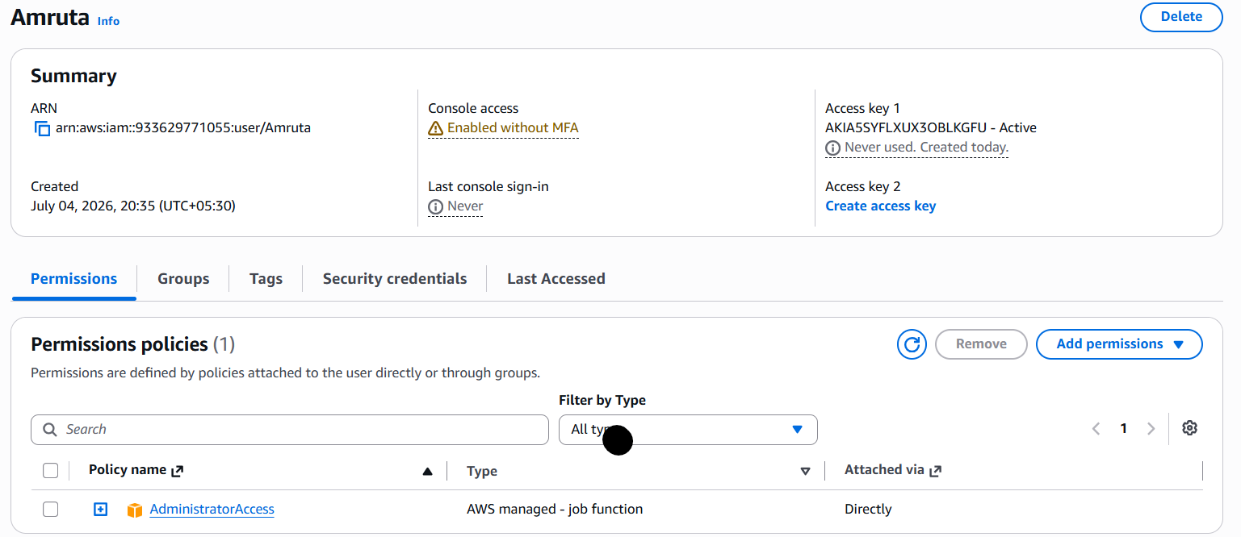

Step 3: Install AWS CLI
Download the AWS CLI installer from the official AWS website. And install it.
Open Command Prompt and verify:
aws --version
Example:
aws-cli/2.35.17
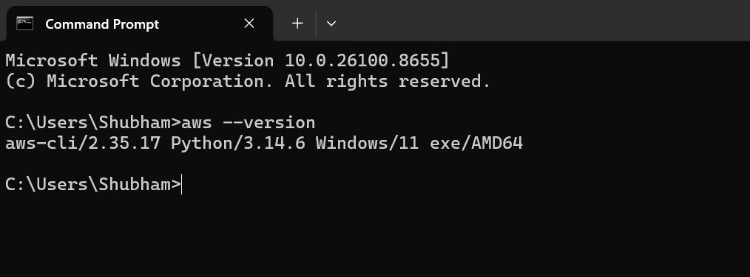
Configure AWS credentials.

aws configure

Then Enter

AWS Access Key, AWS Secret Key, Region , Output format

And Verify using
aws sts get-caller-identity
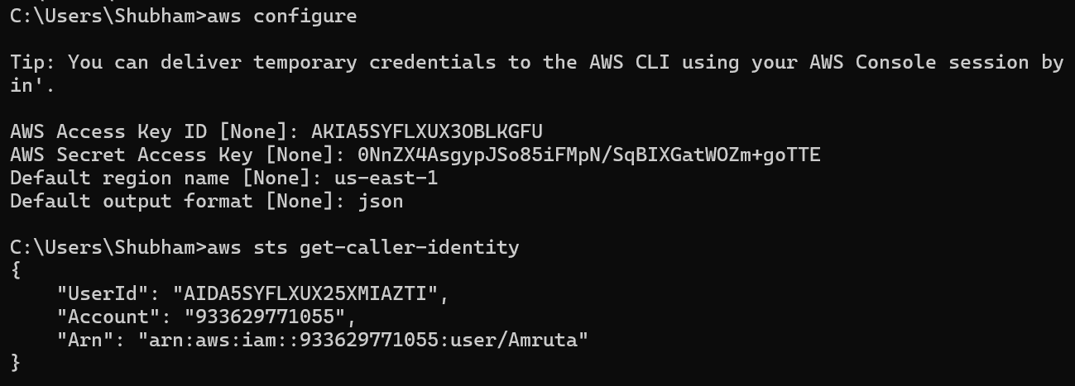

Step 4: Install Terraform
The fastest way to install Terraform is by using built-in Windows deployment tools.
Open PowerShell and run:
winget install HashiCorp.Terraform
Then Verify installation
terraform –version
( If you install Terraform via PowerShell using winget the package manager handles the path registration automatically.)

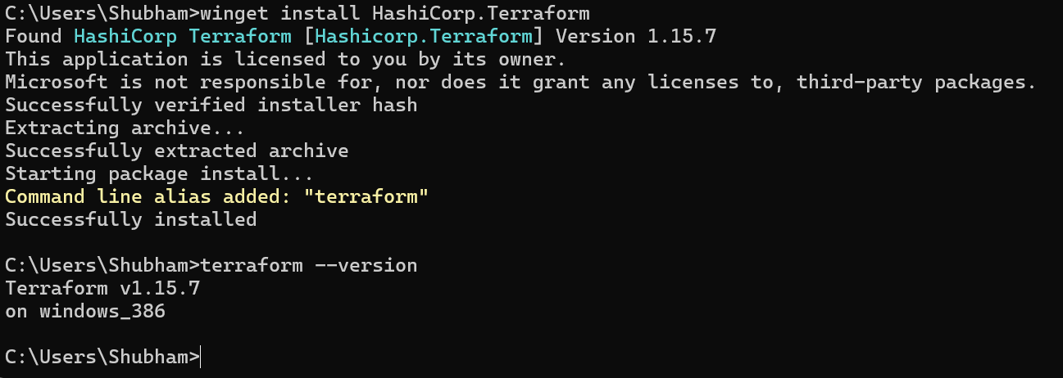

Step 5: Install Visual Studio Code
Download and install Visual Studio Code.
Open VS Code.
Install these extensions:
- HashiCorp Terraform
- AWS Toolkit
- YAML
- Docker

Step 6: Install Git
Download Git for Windows.
Verify:
git ––version
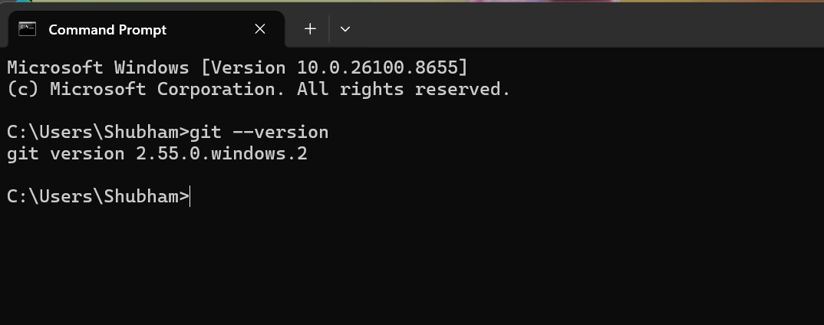

Step 7: Create Project Folder
Create a folder:
Terraform-Infrastructure-Automation
Open it in VS Code.
And now project is ready.

Step 8: Create Terraform Files
Create the following files:
Terraform-Infrastructure-Automation
│
├── provider.tf
├── main.tf
├── variables.tf
├── outputs.tf
├── terraform.tfvars
├── versions.tf
├── .gitignore

Step 9: Write Terraform Files

Now we start writing our terraform file.

Created following files and uploaded to github repository
1. versions.tf

2. provider.tf

3. variables.tf

4. terraform.tfvars

5. .gitignore

Step 10: Initialize Terraform
Open the terminal in VS code and use command:
terraform init

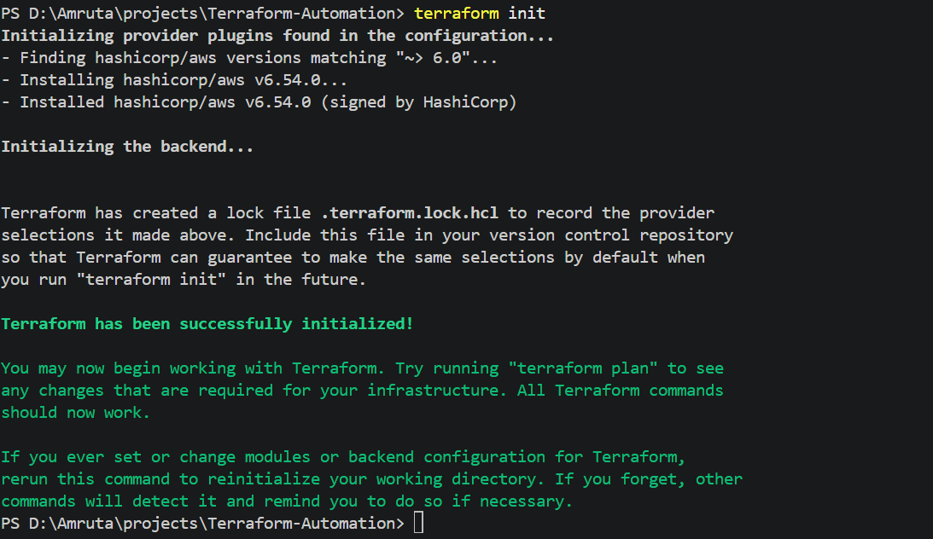

When we perform terraform init, terraform will do :
1. Reads versions.tf
2. Downloads the AWS provider
3. Creates a .terraform directory

4. Creates .terraform.lock.hcl

We can see changes in folder

Step 11: Validate the Configuration then Format the Files
Run:
terraform validate

terraform fmt
Terraform automatically formats all .tf files.

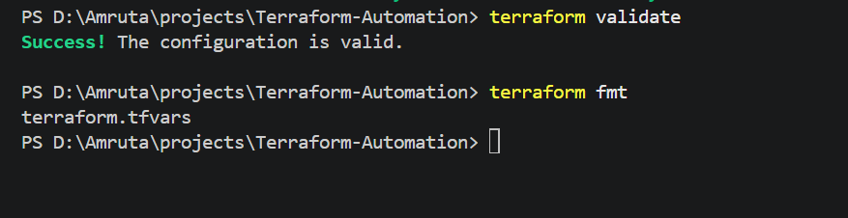

Step 12: Check the Execution Plan
Run:
terraform plan
Since there are no resources yet, you'll see:
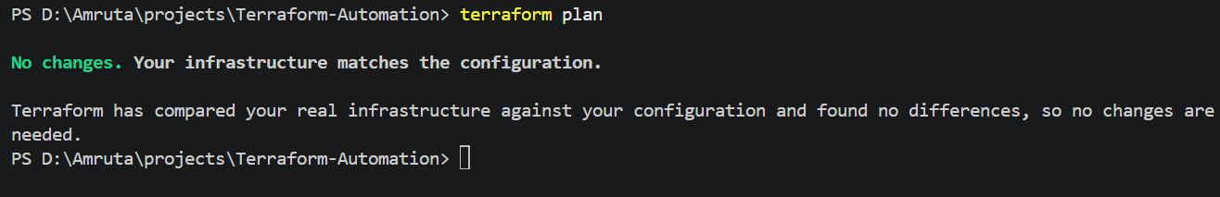
Step 13: Write main.tf
Here now we start creating AWS resources like Ec2 instance, VPC, Subnet, Internet Gateway, Route Table Check the github repository for main.tf
Step 14: Run Terraform
terraform plan
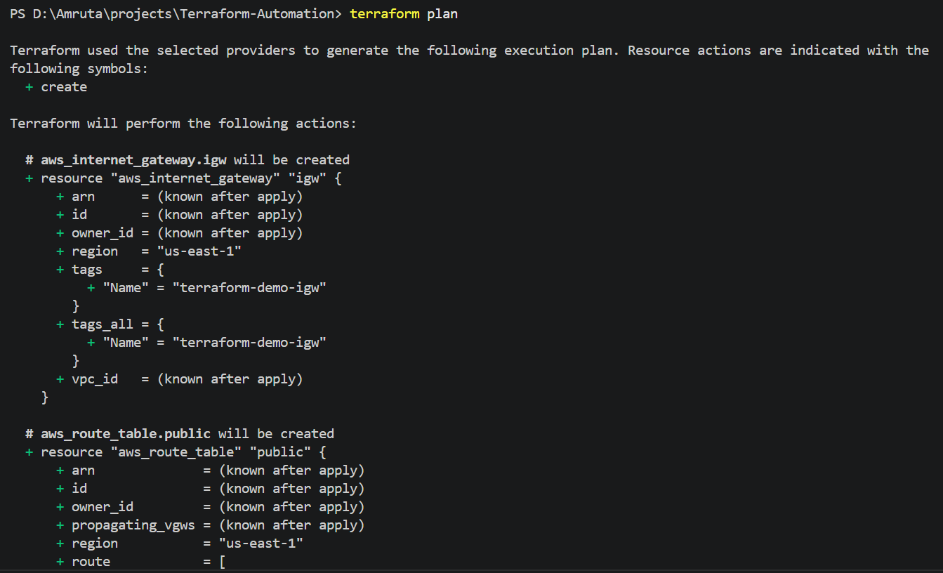

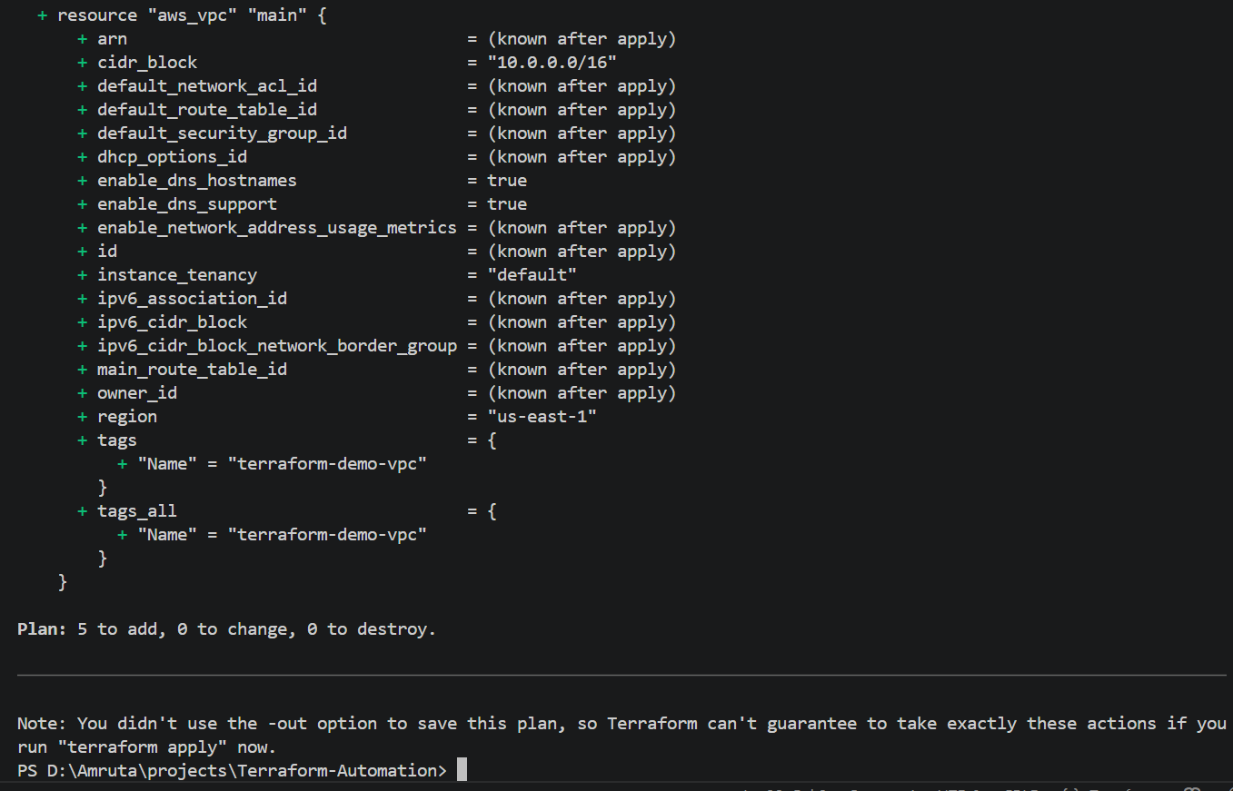
Then
terraform apply
Step 15: Verify in AWS
After the apply finishes, open the AWS Console and verify:
- VPC → A new VPC named terraform-demo-vpc
- Subnets → A public subnet
- Internet Gateways → An attached Internet Gateway
- Route Tables → A route to 0.0.0.0/0 through the Internet Gateway
- Ec2 instance →
  - EC2 instance is Running
  - Public IPv4 address is assigned
  - Security Group is attached
  - Key Pair is terraform-key

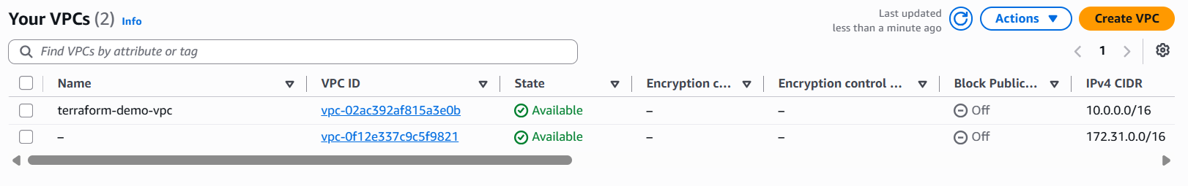
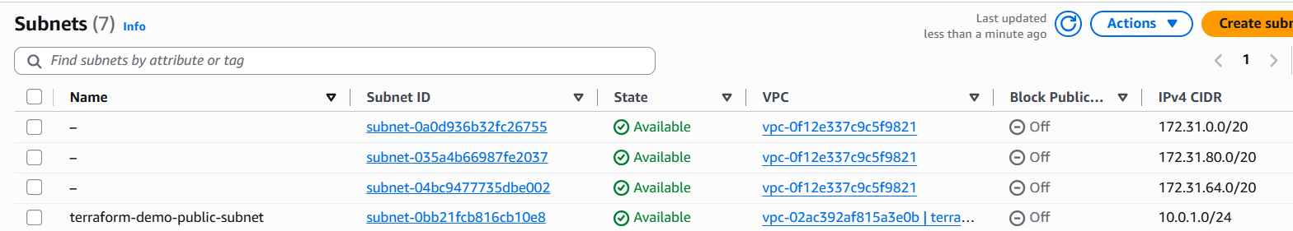

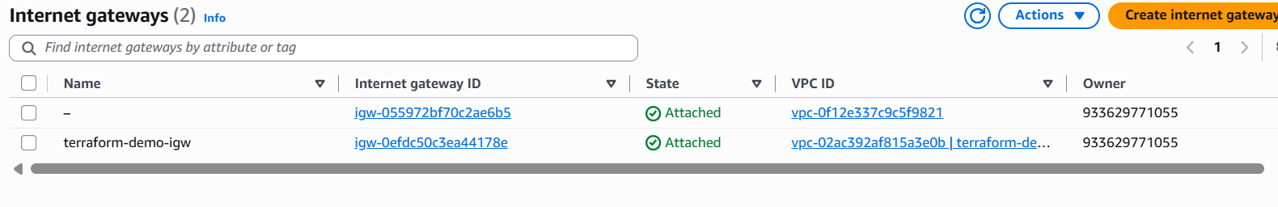
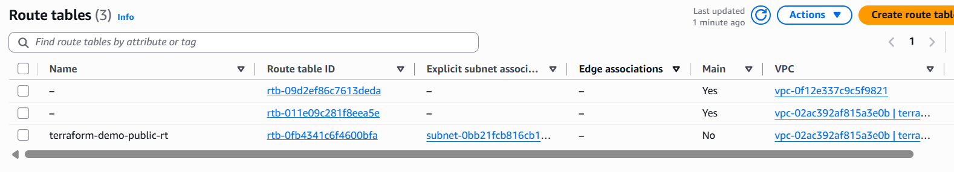
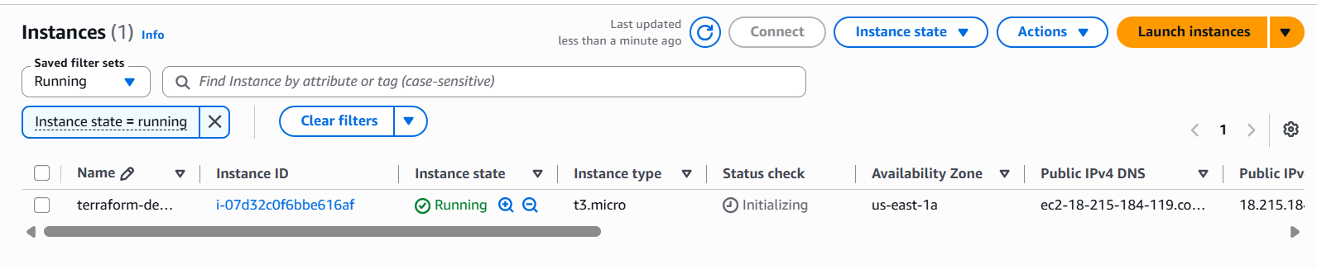

Step 16: Test the Website
Copy the EC2 Public IP.
Open a browser:
http://<EC2-PUBLIC-IP>
